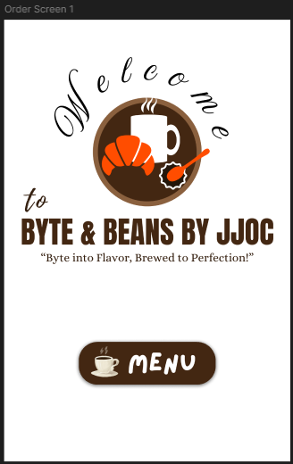

**Welcome Screen/Entry Point**

This is the first screen that customers see. The customers can see the restaurant’s branding and a *MENU* button where customer’s tap so they can be taken to the Menu Selection screen.

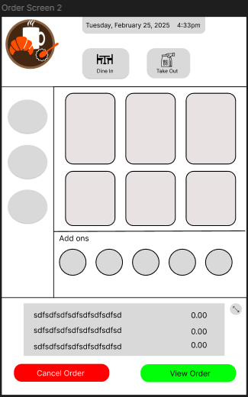

**Menu Selection**

This is where customers see the list of available food and drinks in a interactive grid. The customers can select items that they want to order or add. After selecting the item, they can choose whether to cancel, where they are taken back to the welcome screen or the View order, where they will be taken to the order review.

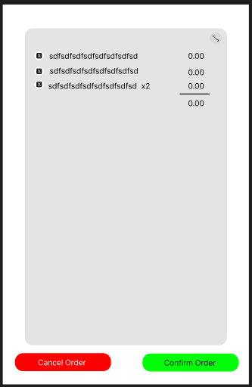

**Order Review**

This displays the selected items, the quantity and the total price before placing or confirming the order. The customer has two options to choose from, which is the cancel and confirm order.

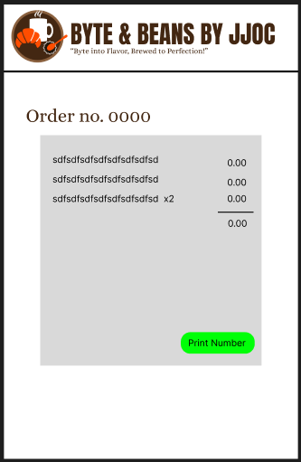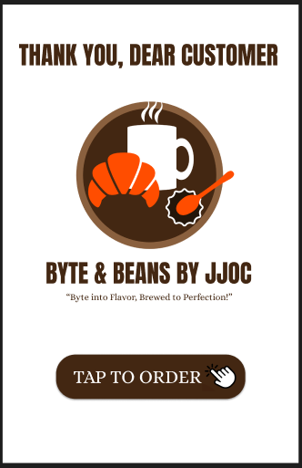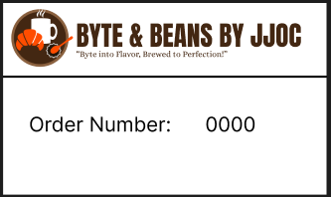

**Order Confirmation**

After confirming the order, the system will generate an order number for reference and displays the order details for review. The customer then taps the **Print Order** which prints the order number.

**Order queueing number**

This prints the queueing number that will be used for pickup. This will help for the staffs and customer to track their orders.

**Order Completion**

This displays a Thank you screen which confirms the successful order of the customer. The **Tap to Order** button will help the next customer to navigate back to the welcome screen.